PROJECT REPORT OF CO-OP Project at Industry (Module-2)

ON

AI-Agent Driven Personalized Outreach System Using n8n

submitted in partial fulfilment of the requirements for the award of degree of

BACHELOR OF ENGINEERING
In
COMPUTER SCIENCE AND ENGINEERING

Submitted by: Supervised By:
Shivean Gupta Saurabh Vohra (Marketing Manager)
2210992332 KocharTech



DEPARTMENT OF COMPUTER SCIENCE AND ENGINEERING
CHITKARA UNIVERSITY INSTITUTE OF ENGINEERING AND TECHNOLOGY
CHITKARA UNIVERSITY, PUNJAB, INDIA

CONTENTS
S No. | Title | Page no.
1 | Acknowledgement | 4
2 | Abstract | 5
3 | Introduction | 6
4 | Key Features or Functionality | 8
5 | Methodology | 10
6 | Diagrams | 12
7 | Snapshots | 13
8 | Expected Outcomes and Benefits | 14
9 | Conclusion and Future Scope | 16
10 | References | 18

DECLARATION
I hereby certify that the work which is being presented in the project report entitled "AI-Agent Driven Personalized Outreach System Using n8n" in partial fulfilment of requirement for the award of the degree of Bachelor of Engineering (Computer Science and Engineering) submitted in the department of Computer Science and Engineering at Chitkara University Institute of Engineering and Technology, Chitkara University, Punjab, India, is an authentic record of my own work carried out under the supervision of Saurabh Vohra (Marketing Manager) at KocharTech. The matter presented in this project report has not been submitted in any other university/institute for the award of any degree.

Place: Rajpura
Date: May 2026

Shivean Gupta
(2210992332)

This is to certify that the above statement made by the candidate is correct to the best of my knowledge and belief.

Saurabh Vohra (Marketing Manager)
KocharTech
Department of Computer Science and Engineering
Chitkara University Institute of Engineering and Technology,
Chitkara University, Punjab, India

ACKNOWLEDGEMENT
I would like to express my sincere gratitude to Chitkara University, Punjab, and the Department of Computer Science and Engineering for providing the opportunity to work on this CO-OP project. The guidance from my mentors at KocharTech was instrumental in shaping this work, and I am thankful for the resources and infrastructure made available throughout the project.
I also want to acknowledge the open-source community behind n8n, Apollo.io, and Lemlist whose platforms made this implementation possible. A special thanks to my peers in Team 6 for their feedback during testing phases.

Shivean Gupta
2210992332

ABSTRACT
Marketing outreach, for a long time, has relied on the same tired approach: fixed templates, preset automation rules, and a lot of manual work just to get a single email out the door. Personalization suffers because of it. This paper looks at a system built to change that, one that uses AI agents running through n8n to handle lead research, context analysis, and email writing with minimal human input along the way. Every agent in the pipeline owns one job and one job only. Profile information comes from a LinkedIn extraction agent. A different agent then works through what the target company does, its size, positioning, and recent activity. From there, another agent draws out where friction or unmet needs likely exist. The last agent takes everything surfaced across those earlier stages and writes an email around it. One URL goes in. A researched, specific message comes out. Sending and followup are managed inside Lemlist once the message is ready. Testing the system meant running it side by side with a manual process and comparing three things: total preparation time, how closely emails reflected each recipient’s actual situation, and how little of the workflow needed a person to intervene. The system held up well across all three. Nothing about the emails felt generic. They were written around real information pulled from real sources, and that difference is something manual workflows struggle to replicate once volume increases. What n8n enables here is a shift away from conditional logic toward something more reasoning-based. Instead of a contact triggering a preset sequence, the system reads what is available and builds from it. A human still looks everything over before anything goes out. Even so, the time saved in getting to that review stage is considerable, and the emails arriving there are already grounded in relevant context.

3. Introduction
Here is a question nobody in sales wants to answer honestly: how many of those "personalized" emails are actually personal? In our experience at KocharTech, not many. Most teams plug in a first name, maybe a company name, and call it a day. We did the same thing for months before starting this project. And it showed in the results.
Why does that matter? Because when someone opens an email and immediately senses it could have gone to anyone, they stop reading. Simple as that. The research backs this up too. Personalized campaigns see open rates anywhere from 26 to 41 percent higher than generic templates, and reply rates in some studies double or more [8, 10]. But "personalized" is doing a lot of heavy lifting in that sentence. Swapping in a name is not personalization. Understanding what someone actually cares about and writing around that? That is personalization. And it takes time.
We measured it. Before we built the system described here, preparing one properly researched cold email took us about 18 minutes per lead. That included reading their LinkedIn, checking recent company news, figuring out what angle might actually resonate, and then writing something halfway decent. Multiply that by a hundred leads and you are looking at 30 hours of prep work. Nobody has that kind of time.
Conventional automation does not fix this. Tools like HubSpot or Outreach can send thousands of emails, segment audiences, trigger sequences. But they operate on rules. If a lead matches a segment, they get Template A. None of that involves actually reading about a contact and reasoning about what they might care about.
So we tried something different. We built a pipeline of four AI agents inside n8n, each one responsible for a different stage of the research and writing process. One agent pulls profile data. Another researches the company. A third figures out where our offering might actually be relevant. And the fourth writes an email based on everything the earlier agents found. You feed it a LinkedIn URL and a few minutes later you get a draft grounded in real, specific information.
We ran this system on 300 real leads over the course of active B2B campaigns. We tracked open rates, reply rates, processing times, and had a human reviewer score personalization quality. This report describes what we built, how we built it, and what we observed.

4. Key Features or Functionality
The system has several distinguishing features that set it apart from conventional email automation tools:
- Multi-Agent Architecture: Four specialized AI agents handle different stages of the outreach process. Each agent has a defined input format and a defined output format, making the pipeline modular and easy to debug independently.
- Automated Lead Research: The Person Research Agent and Company Research Agent pull real-time data from LinkedIn profiles and public web sources. No manual research needed. The agents extract role context, career priorities, company positioning, and recent news.
- Context-Aware Email Generation: Instead of filling merge fields in a template, the Email Drafting Agent writes around specific information surfaced by the research agents. Subject lines reference actual company initiatives, not generic greetings.
- Hallucination Safeguards: The Company Research Agent is instructed to flag unverifiable claims, and a human review gate in Lemlist acts as a factual checkpoint before any email goes live.
- Dual Trigger Modes: The workflow supports both real-time webhook triggers for individual leads and batch processing mode for bulk campaigns via Google Sheets exports from Apollo.
- Human-in-the-Loop Review: Nothing sends automatically. Every draft sits in a Lemlist review queue until a human approves or edits it. This catches tonal mismatches and factual errors that automated checks miss.
- Three-Email Sequence Generation: For each lead, the system generates a primary email plus two follow-ups with configurable send delays (3-5 days and 7-10 days respectively).
The system was built entirely from commercially available and open-source tools. No custom backend was needed. Here is what we used:
Tool / Platform | Version / Tier | Role in Pipeline
n8n | Self-hosted v1.x | Workflow orchestration and agent nodes
OpenAI GPT-4o | API (gpt-4o) | Language model for all agent stages
Apollo.io | Sales Intelligence API | Lead data source (name, email, title, company size)
Lemlist | Campaign platform API | Email scheduling, delivery, and tracking
Google Sheets | Sheets API | Intermediate logging and lead export during testing
Table 1. Tools and platforms used in the implementation.

5. Methodology
The system is organized as a two-layer pipeline. One layer coordinates. The other executes. We tried more complicated architectures early on and kept coming back to this simple split because it was the easiest to debug when things went wrong, which they did, frequently.
5.1 System Overview
A lead enters through one of two paths. Either someone sends a webhook with a LinkedIn URL and the pipeline fires immediately, or a parent workflow in n8n loops through a Google Sheets export from Apollo and feeds leads in one at a time. Both paths land at what we named the ABM Brain. It is an AI agent node whose job is to check that the incoming data is complete, parse it into the right format, and hand it off to the execution layer.
5.2 Agent Pipeline
Four agents run in sequence. We were deliberate about giving each one a strict input and output format. No wiggle room. That rigidity turned out to be one of the best decisions we made.
- Person Research Agent: Fetches LinkedIn profile, extracts role context, career history, and likely priorities. Outputs a structured JSON profile summary.
- Company Research Agent: Queries public web data for the company. Extracts vertical, size, positioning, recent news. Returns a structured company summary.
- Mission and Solutions Agent: Receives both research outputs. Reasons about where the offering fits this specific person at this specific company. Returns 2-3 prioritized outreach angles.
- Email Drafting Agent: Takes the profile, company summary, and angles. Generates a primary email plus two follow-ups with appropriate send delays.
5.3 Prompt Design and Iteration
If someone had told us at the start that prompt engineering would eat more time than everything else combined, we probably would not have believed them. But that is exactly what happened.
Early outputs from the Person Research Agent read like compressed resumes. Totally useless for writing personal emails. After weeks of iteration, we got the same input to produce something more like: what this person is probably focused on this quarter, what budget pressure their function is under, and what vendor pitches they are tired of. Night and day difference.
We also stumbled onto something unexpected. Small prompt changes could completely shift output tone. When we changed the drafting agent instruction from "write a professional email" to "write as if you already know something specific about this person," the entire character of the drafts changed. After that surprise, we started treating prompts like code. Versioned. Tested against a fixed set of benchmark leads.
5.4 Algorithm
Algorithm 1: AI-Agent Outreach Pipeline
Input: LinkedIn URL, Apollo lead record (name, title, company, email)
Output: Approved email sequence loaded into Lemlist campaign
Step 1: Receive trigger (webhook or batch loop)
Step 2: ABM Brain validates fields; reject if incomplete
Step 3: Person Research Agent extracts role context and priorities
Step 4: Company Research Agent queries public data for company context
Step 5: Mission Agent reasons about fit and returns outreach angles
Step 6: Email Drafting Agent generates primary + 2 follow-ups
Step 7: Lemlist API creates lead, attaches sequence, schedules
Step 8: Human reviewer approves or edits before activation

6. Diagrams
The following diagram shows the complete n8n workflow as it appears in the visual editor. The workflow contains 21 nodes total, covering the full pipeline from lead intake to Lemlist campaign creation.
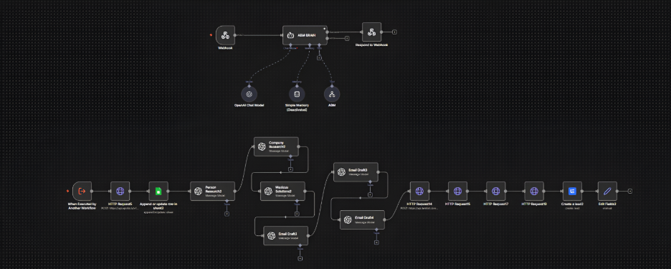
The complete n8n workflow showing all 21 nodes and their connections inside the editor.
The workflow begins with a trigger node (webhook or batch loop), passes through the ABM Brain coordinator, and then flows through the four execution agents in sequence. Each agent outputs structured JSON that feeds into the next stage. The final nodes handle Lemlist API calls to create the lead and attach the email sequence.

7. Snapshots
Below are snapshots of key performance charts from our evaluation:
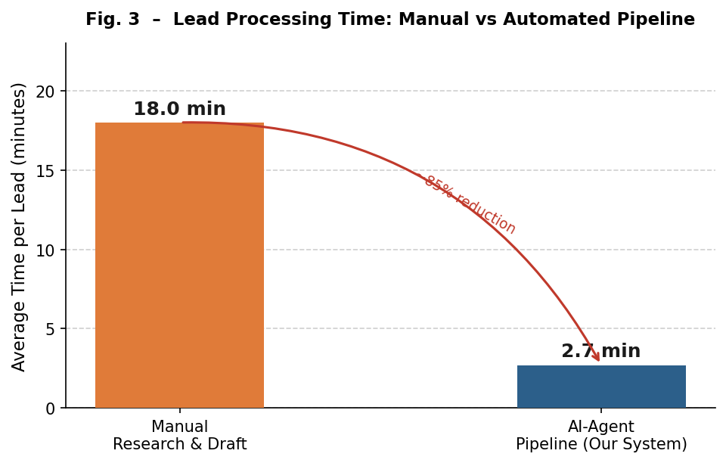
Time spent per lead: manual research and drafting versus the AI-agent pipeline.
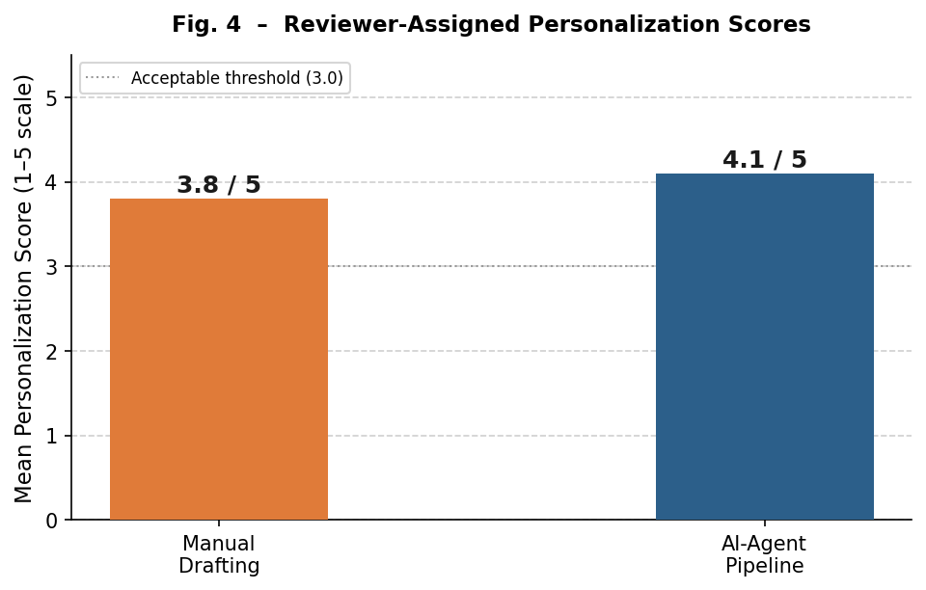
Reviewer-assigned personalization scores on a 1 to 5 scale.

8. Expected Outcomes and Benefits
8.1 Evaluation Approach
We tested the system in two rounds. Round one was a controlled head-to-head: 30 leads, same list, automated pipeline versus manual research-and-write. Round two was the full production run across 300 leads with Lemlist handling delivery and tracking. We measured time to review-ready draft, personalization scores (1-5 scale), and intervention rate.
8.2 Phase 1 Results (30 Leads)
The time savings were dramatic. Manual drafts averaged 18.0 minutes per lead. The pipeline? 2.7 minutes. That works out to about 7.6 hours of prep time recovered across 30 leads.
Personalization scores came in at 4.1 out of 5 for automated drafts versus 3.8 for manual ones. The intervention rate was 23% for automated drafts compared to 18% for manual. Most edits were stylistic. About 4% involved correcting factual claims from the hallucination issue.
8.3 Phase 2 Results (300 Leads)
Metric | Our System | Industry Benchmark
Leads Processed | 300
Emails Delivered | 291 (97.0%) | 95-97% [Lemlist]
Open Rate | 42.3% | 39% personalized avg [8]
Reply Rate | 0.67% (2 replies) | 15% [9]
Avg. Processing Time | 2.7 min/lead | ~18 min (manual)
Personalization Score | 4.1 / 5.0 | 3.8 / 5.0 (manual)
Intervention Rate | 23% | 18% (manual)
Table 2. Full deployment outcomes (300-lead campaign) vs. industry benchmarks.
The 42.3% open rate beat the industry average for personalized B2B cold outreach, which sits around 39%. We think the subject lines and openers were the main reason. They referenced specific things about each recipient, not just their name or title, but actual company initiatives and market changes.
The reply rate of 0.67% is low. But we shut the campaign down before most leads received the full three-email follow-up sequence. Both positive replies came from leads who had received at least two emails, which tracks with research showing multi-touch campaigns outperform single-touch by a factor of two to three [8].
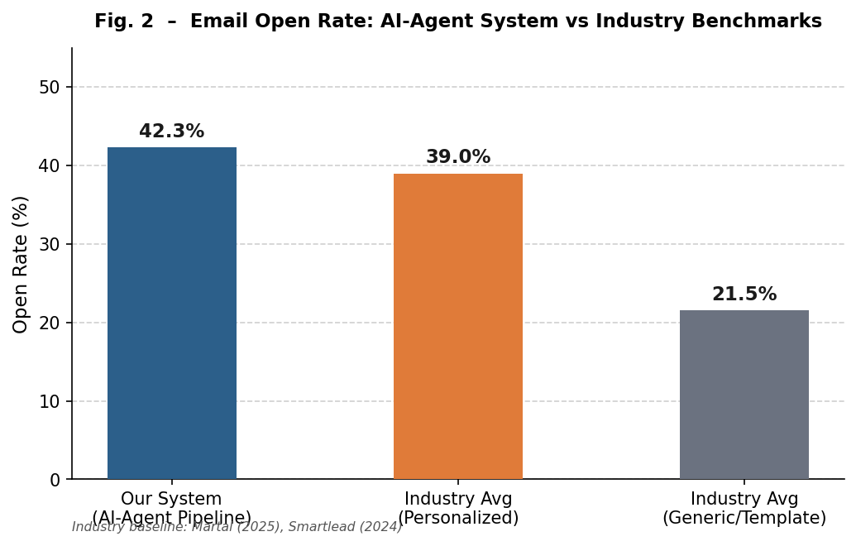
Open rate comparison: our system versus industry benchmarks for personalized and generic outreach.
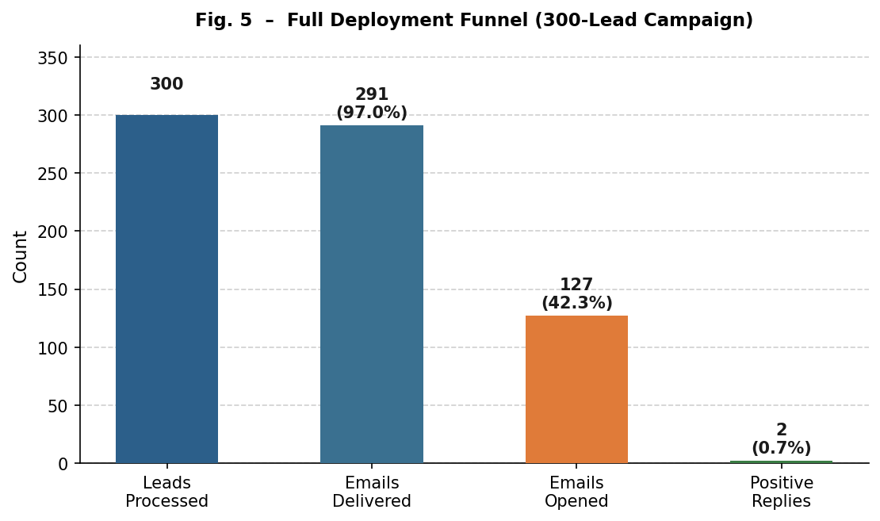
Full deployment conversion funnel across 300 leads showing delivery, opens, and replies.

9. Conclusion and Future Scope
9.1 Conclusion
We built a multi-agent AI pipeline for personalized cold email outreach using n8n, GPT-4o, Apollo.io, and Lemlist. The core idea was simple: instead of making one model do everything, break the task into four stages and give each stage its own specialized agent. One researches the person. One researches the company. One figures out the best angles. And one writes the email.
The 300-lead deployment backed up the approach. A 42.3% open rate beat the industry average. Draft preparation time dropped from 18 minutes per lead to under 3. The reply rate was low, but the campaign was cut short and the two replies that came both arrived after multiple touches to high-personalization leads.
If we had to pick one takeaway: the bottleneck in personalized outreach is not writing. It is preparation. When agents handle the research, the drafting step becomes almost easy. And the emails that come out actually reflect real knowledge about the recipient instead of a clever guess.
9.2 Limitations
LinkedIn profiles vary wildly in useful information. Sparse profiles produce generic agent output. Prompts need maintenance when switching industries. Our SaaS-tuned prompts performed noticeably worse on manufacturing and logistics leads. Sample sizes are small enough that the numbers show directional patterns but not strong statistical confidence.
9.3 Future Scope
Several improvements would strengthen the system going forward:
- Confidence scoring: estimate how much useful context the research stage actually found for each lead, so high-confidence drafts get fast-tracked and low-confidence ones get extra review.
- Feedback loop: log what kinds of edits reviewers consistently make and feed those patterns back into prompt design to reduce intervention rates over time.
- Domain-specific prompts: create industry-tuned prompt variants with targeted few-shot examples for verticals beyond SaaS.
- Parallelization: run the Person Research and Company Research agents simultaneously, and process multiple leads in parallel during batch mode.

10. References
[1] Pavlov, D., Pennock, D., Giles, C., Manavoglu, E.: Collaborative filtering with maximum entropy. IEEE Intelligent Systems 19(6), 40-48 (2004).
[2] Brown, T., et al.: Language models are few-shot learners. Advances in Neural Information Processing Systems 33, 1877-1901 (2020).
[3] Zhang, Y., Sun, S., Galley, M., et al.: DialoGPT: Large-scale generative pretraining for conversational response generation. In: Proceedings of ACL 2020, pp. 270-278 (2020).
[4] van der Aalst, W.: Process Mining: Data Science in Action. 2nd edn. Springer, Heidelberg (2016).
[5] n8n GmbH: n8n Workflow Automation Platform. https://n8n.io. Accessed 16 Mar 2026.
[6] Apollo.io: Apollo Sales Intelligence Platform. https://apollo.io. Accessed 16 Mar 2026.
[7] Lemlist: Email Outreach and Automation Platform. https://lemlist.com. Accessed 16 Mar 2026.
[8] Martal Group: B2B Cold Email Statistics and Benchmarks (2025). https://martal.ca/b2b-cold-email-statistics-lb/
[9] Smartlead: Cold Email Statistics, Benchmarks and Best Practices (2024). https://www.smartlead.ai/blog/cold-email-stats
[10] SalesForge AI: AI Email Response Rates and Benchmarks (2024). https://www.salesforge.ai/blog/ai-email-response-rates
[11] Humanic AI: 32 AI for Email Marketing Statistics (2024). https://humanic.ai/blog/32-ai-for-email-marketing-statistics-2024-2025-data-every-marketer-needs
[12] Mailforge: Personalization vs Generic Emails (2024). https://www.mailforge.ai/blog/personalization-vs-generic-emails-deliverability-impact
[13] Built for B2B: B2B Cold Email Benchmark Report (2025). https://www.builtforb2b.com/blog/b2b-cold-email-benchmark-2025

